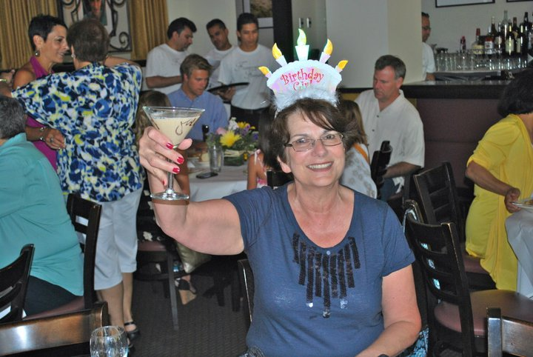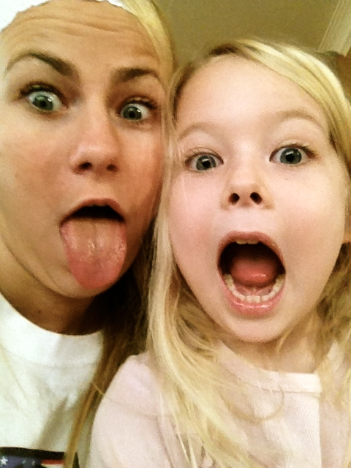

**Youth has no age!**

**Indulge in sweets with no fear.**

**Enjoy youthful activities.**

**Surround yourself with happy people.**

**Be adventurous.**

**Watch Disney movies.**

**Dress how you want.**

**Sleep in.**

**Pg. 103**

Celebrating You Magazine

April, 2014

Young, wild and FREE!

How to feel young again!

*“Enjoy your youth. You’ll never be younger than you are at this very moment!” pg. 71*

# YOUTH